Technology Tools for Secondary Mathematics
MCTM Spring Conference May 3rd, 2014

Presenters: Dr. Tim Harms, Monica Maus, Joanna Rogness, Holly Amundson, & Ashley Borchardt
Affiliation: Minnesota State University Moorhead
Website: http://msum-mctm.weebly.com/

ArmBot - Cartesian and Polar Coordinates
Minnesota State Standard:
Benchmark: 9.3.2.5 Technology Tools
Use technology tools to examine theorems, make and test conjectures, perform constructions and develop mathematical reasoning skills in multi-step problems. The tools may include compass and straight edge, dynamic geometry software, design software or Internet applets.

Cartesian Coordinate System
Polar Coordinate System
(x, y)
(r, θ)
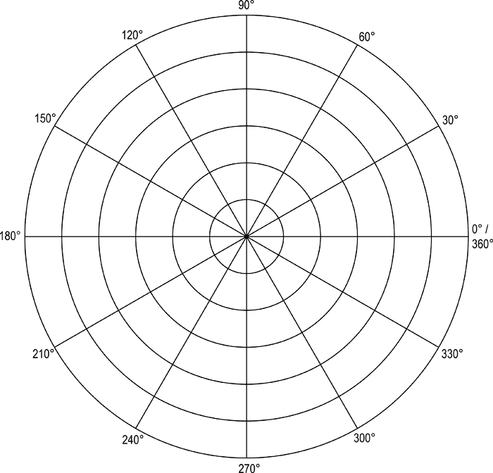
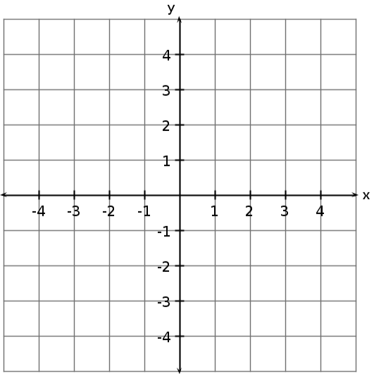

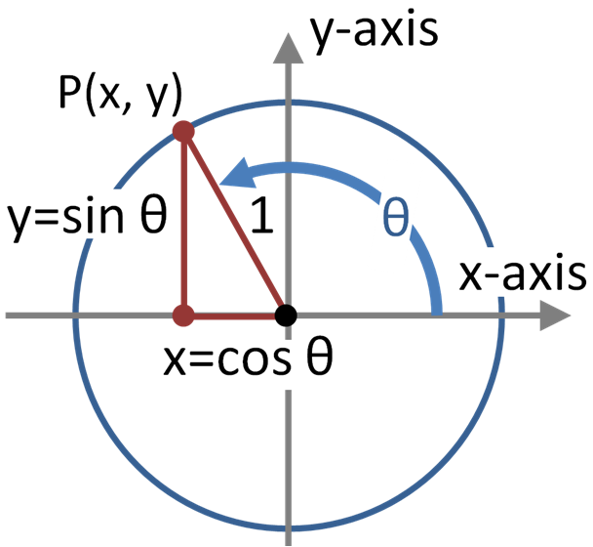
Helpful Equations:
Unit Circle
- $x^{2}+y^{2}=r^{2}$
- $\cos^{2}\left(θ\right)+\sin^{2}\left(θ\right)=1$
- $r=\sqrt{x^{2}+y^{2}}$
- $x=r⋅\cos\left(θ\right)$
- $y=r⋅sin⁡(θ)$
- ${θ=tan}^{-1}\left(\frac{y}{x}\right)$

Squares’ Coordinates - Cartesian:
- Green: (0 , 210)
- Blue: (103.48 , 159.35)
- Red: (-138.96 , 129.58)
- Orange: (-145.01 , 67.62)

Practice:
- Convert from Cartesian coordinates to polar coordinates: (-138.96 , 129.58)

- Convert from polar coordinates to Cartesian coordinates: (160, 155°)

